- What is the process of active transport?
- How do large particles enter or exit cells?
ESSENTIAL QUESTIONS:

- Active Transport
  - Sometimes substance must move ______________ the concentration gradient (from ______ to __________ concentration). This requires ______________ (ATP) and is called active transport.
  - Occurs with the aid of _______________ proteins, often called ____________.
- Example of Active Transport: Na+/K+ ATPase Pumps
  - Found in the ______________ ________________ of animal cells.
  - ________________ levels of sodium (Na+) and potassium (K+) inside/outside the cell.
  - Large molecules like ________________ need to move ______________ a concentration gradient to get into the cell.
  - In a process called _______________ _______________, sugars can pair with Na+ ions and enter the cell through a ________________ protein called a ______________ channel.
  - This allows sugars to enter through ___________________ _________________ - saving energy.
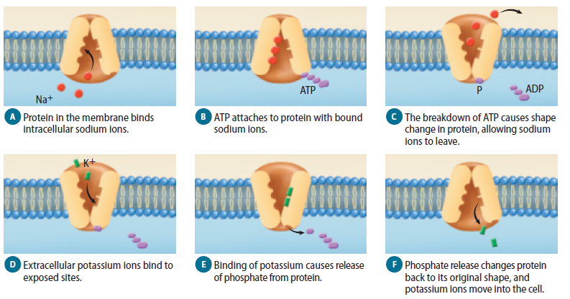
- Transport of Large Particles
  - Endocytosis is the process by which a cell _______________ an object in the _______________ environment in a portion of the plasma membrane.
  - Exocytosis is the _________________ of materials at the plasma membrane.

