- What are the processes of diffusion and facilitated diffusion?
- What is the effect of a hypotonic, hypertonic, or isotonic solution on a cell?
ESSENTIAL QUESTIONS:

- Particles in solids, liquids, and gasses are in ______________ random ______________.
- Diffusion is the net _________________ of particles from an area of ________ concentration to an area of _______________ concentration.
  - This does not require additional _____________ because the particles are already in ______________.
- When diffusion occurs over a long enough time, concentrations will become _______________, and the solutions will reach dynamic equilibrium.
  - Molecules continue to __________, but the overall concentration stays the _________.
- _______________ can diffuse across the plasma membrane, but most other substances cannot.
- Facilitated diffusion uses _______________ _______________ to move ions and small molecules across the plasma membrane.
- Diffusion and facilitated diffusion are types of ______________ transport – they require no additional ________________.
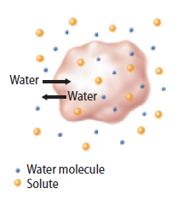
- Osmosis is the diffusion or movement of _____________ across a selectively permeable membrane.
ISOTONIC:
  - It will move until the concentration of ____________ is the same on both sides.
- Cells in an isotonic solution have the __________ concentration of water and solutes inside and out of the cell.
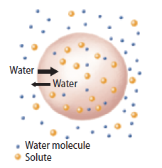
  - Water still ___________ through the membrane, but it enters and leaves at the ________ ___________.
HYPOTONIC:
- Cells in a hypotonic solution __________ water because there is a _____________ concentration of solutes outside of the cell.
  - As water moves int the cell, _______________ increases.
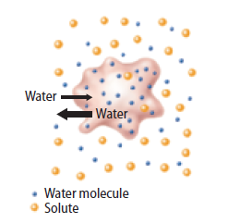
  - Animal cells can _____________ when placed in extremely hypotonic solutions.
HYPERTONIC:
- Cells in a hypertonic solution _______ water because there is a _____________ concentration of solutes outside the cell than within.
  - As water moves out of the cell, _______________ decreases, which causes ______________ in plants.

